Cochran Archives 30/5/2022

Links to journal articles cited or contained in files imperfect

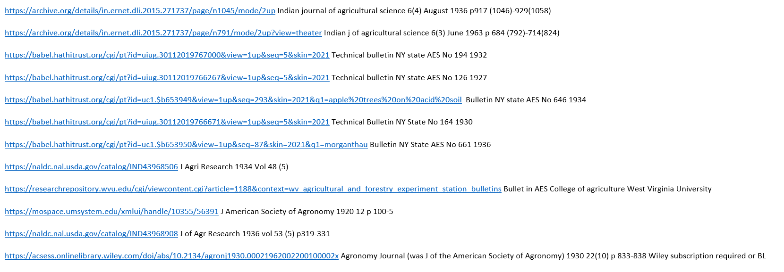

Other reprints

The Journal of the National Institute of Agricultural Botany No 3 1925 whole issue

Archief voor der suikerindustrie in Nederlandsch-Indie Series 3 1932 No 14 issue